Direct Reprogramming: Bypassing Stem Cells for Therapeutics

July 7, 2015

Eduardo Marbán, MD, PhD¹; Eugenio Cingolani, MD¹

SCIENTIFIC DISCOVERY AND THE FUTURE OF MEDICINE

During fetal growth, cells differentiate into various types, such as cardiomyocytes and neurons, through an intricately orchestrated set of genetic and epigenetic instructions, with the input of developmental cues. Once cells migrate to their adult destination, they are highly differentiated. Cardiomyocytes beat away year after year; neurons make memories; hepatocytes clear toxins. The function of these cells remains unchanged until they die naturally or as a consequence of disease. Many tissues contain intrinsic progenitor cells that repopulate the key working cells of that tissue as they die; satellite cells in skeletal muscle are but one example. Yet even such progenitor cells have a limited number of possible fates. Advances in science now make it feasible, in many cases, to redirect cell fate: fibroblasts in the heart can become working cardiomyocytes, and pancreatic exocrine cells can turn into beta cells.

STEMNESS
Stem cells are primitive cells that can give rise to a diversity of offspring, few of which resemble the parent cell. The ultimate stem cell is the fertilized ovum, from which the entire organism is created. Such cells are “pluripotent,” meaning that they can produce the full repertoire of cells in the adult. Embryonic stem cells from blastocysts were the first pluripotent cells to be harvested by laboratory scientists. Being from a preimplantation embryo, such cells are naturally equipped for pluripotency.
In principle, all tissues and organs in the body could be recreated from embryonic stem cells, but a number of practical concerns have restricted in vivo applications. Chief among these are immunological concerns (embryonic stem cells carry all the antigenic hallmarks of a unique individual), and the likelihood of tumorigenesis. The latter necessitates predifferentiation ex vivo into a desired lineage to prevent the development of teratomas. A major shift occurred with the invention of methods to create stem cells from adult cells: fibroblasts transduced with transcription factor genes were able to regain pluripotency.1 This strategy demonstrated the intrinsic plasticity of adult cells previously thought to be terminally differentiated, while suggesting a practical means to overcome immunologic limitations.
But even induced stem cells have limitations. Their very pluripotency turns out to be a challenge: induced pluripotent cells are just as tumorigenic as embryonic stem cells, and, because they can become any type of cell, it may be difficult to make them transform into the desired cell type. This limitation effectively negates treatment with undifferentiated pluripotent cells in humans. Transplantation of predifferentiated cells is required, with safeguards to avoid contamination by even a single rogue pluripotent cell.

DIRECT REPROGRAMMING
In 1987, Davis et al2 demonstrated that the ectopic expression of a single gene, myogenic differentiation 1 (MYOD1), could convert fibroblasts into skeletal muscle cells. This sentinel discovery stood alone for years awaiting generalization, but is now recognized as the first of many demonstrations of direct reprogramming: the ability of an adult cell type to become another without passing through a pluripotent state. Since then, direct reprogramming has been documented both between closely related lineages (eg, various hematopoietic fates) as well as between seemingly unrelated cell types (eg, hepatocytes and neurons).
In general, the more divergent the cell types, the greater the complexity of the reprogramming cocktail (ie, the mixture of transcription factor genes that is necessary), which sometimes includes as many as 9 distinct transcription factors. Transcription factors are genes that are specialized to activate defined genetic programs, so it is not surprising that they may have special utility in direct reprogramming. For in vivo applications, the chosen genes are typically introduced into the target cell packaged into a viral expression vector. Nevertheless, new approaches that are currently being tested use regulatory ribonucleic acids (RNAs), small molecules, epigenetic regulators, or both in lieu of transcription factors. Such alternatives may or may not turn out to be more successful in clinical settings.

TRANSLATION TO THE CLINIC
Direct reprogramming is in various stages of translation (Table). Some ideas that were heralded as potentially revolutionary have failed to advance beyond the initial reports: one such idea is the notion of treating diabetes by changing exocrine pancreatic cells into islet cells.3It is not yet clear why this conceptually attractive approach has stalled in translation. In a more vigorous stage of development are efforts to treat heart failure. The adult mammalian heart heals focal injury, such as that which occurs in myocardial infarction, by scar formation, but scar does not contract, leading to systolic dysfunction and adverse remodeling. Direct reprogramming can convert fibroblasts within the heart into functioning cardiomyocytes.4 The work is more advanced than that involving pancreatic beta cells because various groups have confirmed the findings, the process appears to be operative in human fibroblasts (albeit with extremely low efficiency), and large-animal disease models are being studied. The first use of somatic reprogramming to treat a life-threatening condition, complete heart block, focally injected the transcription factor T-box 18 (TBX18) into the interventricular septum to create a new sinus node as an alternative to electronic pacemakers.5TBX18 was delivered using clinically realistic, minimally invasive methods, enabling late-stage preclinical development (eg, quantification of duration of benefit, off-target effects, etc). Other work seeks to cure deafness by converting ordinary cells in the inner ear into cochlear cells by injection of the atonal homologue 1 (ATOH1) transcription factor.6,7 Phase 1 clinical testing is already under way,8 with the results eagerly awaited.

Direct Reprogramming Application From Proof-of-Concept to the Clinic

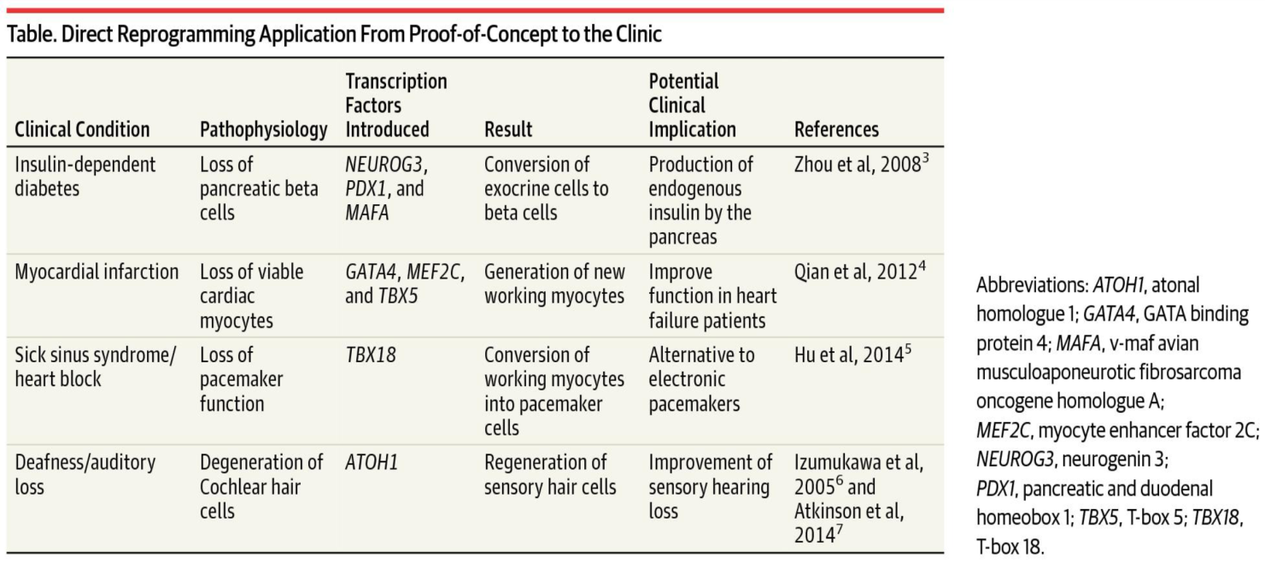

Scientific discoveries like the genome editing system9 (CRISPR-Cas9, GeneArt) and transplantation of predifferentiated stem cells offer the hope of cure for some diseases. Direct reprogramming, reviewed here, adds another therapeutic dimension. The path to cures will be long and complicated, with many challenges, yet the future is bright.

ARTICLE INFORMATION.
Corresponding Author: Eduardo Marbán, MD, PhD, Cedars-Sinai Heart Institute, 127 S San Vicente Blvd, Los Angeles, CA 90048 (eduardo.marban@csmc.edu).
Conflict of Interest Disclosures: All authors have completed and submitted the ICMJE Form for Disclosure of Potential Conflicts of Interest. Dr Marbán reports being the owner and scientific advisor of Capricor Therapeutics. No other disclosures were reported.

REFERENCES
1
Yamanaka S. Nobel lecture: a winding road to pluripotency [video].http://www.nobelprize.org/mediaplayer/index.php?id=1866. Accessed June 4, 2015.
2
Davis RL, Weintraub H, Lassar AB. Expression of a single transfected cDNA converts fibroblasts to myoblasts. Cell. 1987;51(6):987-1000.
PubMed | Link to Article
3
Zhou Q, Brown J, Kanarek A, Rajagopal J, Melton DA. In vivo reprogramming of adult pancreatic exocrine cells to beta cells. Nature. 2008;455(7213):627-632.
PubMed | Link to Article
4
Qian L, Huang Y, Spencer CI, et al. In vivo reprogramming of murine cardiac fibroblasts into induced cardiomyocytes. Nature. 2012;485(7400):593-598.
PubMed | Link to Article
5
Hu YF, Dawkins JF, Cho HC, Marbán E, Cingolani E. Biological pacemaker created by minimally invasive somatic reprogramming in pigs with complete heart block. Sci Transl Med. 2014;6(245):245ra94.
PubMed | Link to Article
6
Izumikawa M, Minoda R, Kawamoto K, et al. Auditory hair cell replacement and hearing improvement by ATOH1 gene therapy in deaf mammals. Nat Med. 2005;11(3):271-276.
PubMed | Link to Article
7
Atkinson PJ, Wise AK, Flynn BO, Nayagam BA, Richardson RT. Hair cell regeneration after ATOH1 gene therapy in the cochlea of profoundly deaf adult guinea pigs. PLoS One. 2014;9(7):e102077.
PubMed | Link to Article
8
Clinicaltrials.gov. Safety, tolerability, and efficacy for CGF166 in patients with bilateral severe-to-profound hearing loss. https://www.clinicaltrials.gov/ct2/show/NCT02132130?term=NCT02132130&rank=1. Accessed June 5, 2015.
9
Doudna JA. Genomic engineering and the future of medicine. JAMA. 2015;313(8):791-792.
PubMed | Link to Article

